National volunteer week 2018 |  | 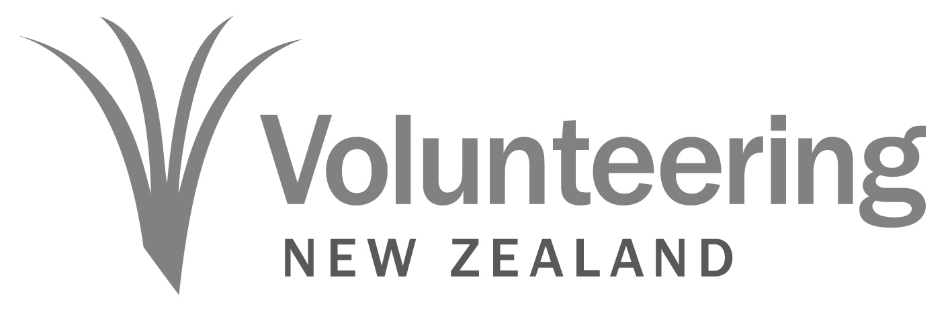

2018 National Volunteer Week Promotional Copy for newsletters, websites, and media
50 words – NATIONAL VOLUNTEER WEEK 2018

National Volunteer Week celebrates the 1.2 million Kiwis who volunteer in our communities every year. The theme for 2018: Volunteers, The Heart of our Community – By many, the work will be completed, Mā tini, mā mano, ka rapa te whai, captures the essence of the volunteering spirit and the essential link between volunteers and the communities who benefit from their generosity. The event will run from June 17-23, 2018.
(69 words)

100 WORDS – national volunteer week 2018
People are the centrepiece of New Zealand’s thriving volunteer community, providing their time, skills and compassion in areas that deeply need it. In many cases, volunteers provide a helping hand in projects that couldn’t be achieved otherwise. National Volunteer Week 2018, held June 17-23, seeks to celebrate those people. This year’s theme: Volunteers, The Heart of our Community – By many, the work will be completed, Mā tini, mā mano, ka rapa te whai, speaks to that.
Additionally, the volunteer work people deliver is essential to keeping our communities strong and healthy. Upwards of 1.2 million people provide a total of 157 million hours per year to volunteer work. Scott Miller, Chief Executive of Volunteering NZ says: “Communities big and small, throughout the country rely on the goodwill and passion that Kiwis have for their communities”.
(135 words)
200 WORDS – national volunteer week 2018
National Volunteer Week celebrates the importance of volunteering in New Zealand and the goodwill of the people who give up their time for it. The theme for this year is: Volunteers, The Heart of our Community – By many, the work will be completed, Mā tini, mā mano, ka rapa te whai. The aim is to remind people of the central and inseparable role of people in keeping volunteering alive.

While the number of Kiwis involved in volunteering has increased over the past decade, the amount of hours worked has decreased. This means, now more than ever, the immensely positive impact of volunteering, felt throughout our communities, the economy and the people themselves needs to be highlighted.

More than simply providing programmes and services, the volunteer industry strengthens community bonds while also extending and deepening the public’s engagement with their regions.

Scott Miller, Chief Executive of Volunteering NZ says: “Communities big and small, throughout the country rely on the goodwill and passion that Kiwis have for their communities”. The theme for National Volunteer Week 2018 highlights the human side of volunteering, showing people not only is volunteering good, it’s good for you and your community.

National Volunteer Week 2018 will be happening over June 17-23.

(194 words)

sample social media posts
National Volunteer Week celebrates that volunteers really are the heart of the community #NVW2018
Volunteers are not only the heart of the community, they are a community of 1 million kiwis #NVW2018
Celebrate National Volunteer Week and recognise volunteers in your community #NVW2018
National Volunteer Week is a great opportunity to become a volunteer. Making a difference in your community is easy #NVW2018
Making a difference in your community is easy when you volunteer #NVW2018
Volunteer. Make a difference in your community #NVW2018

