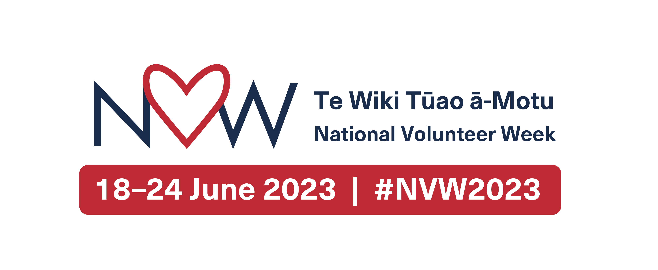

National Volunteer Week I Te Wiki Tūao ā-Motu
- Communications Pack

18-24 June 2023

- Copy
- Printables
- Editable templates
- Hearts and stars
- Volunteering statistics
- Contact information.

Every year Volunteering New Zealand leads the National Volunteer Week (NVW) campaign. NVW is an opportunity to celebrate and recognise all volunteers throughout Aotearoa, New Zealand.

To help you run your own NVW events and celebrations, Volunteering New Zealand has created a communications pack with everything you need.

COPY

National Volunteer Week 18-24 June 2023 honours the collective energies and mana of all our volunteers in Aotearoa.
This Te Wiki Tūao ā-Motu - National Volunteer week, the theme is ‘Time to Shine - He wā pīataata.’ Let’s thank volunteers for the difference they make and the impact they have on our communities.
It’s also time to shine a light on the value of volunteering – which contributes an estimated $4 billion to the New Zealand economy – yet it is under-resourced and under-valued.

Volunteer infrastructure and management needs to be recognised and valued so that volunteering is supported.

>> Download 50, 100, 200 words

PRINTABLES – Ready-to-use

Create your own printable Certificates and Thank you cards.

>> Download here
NVW logo:

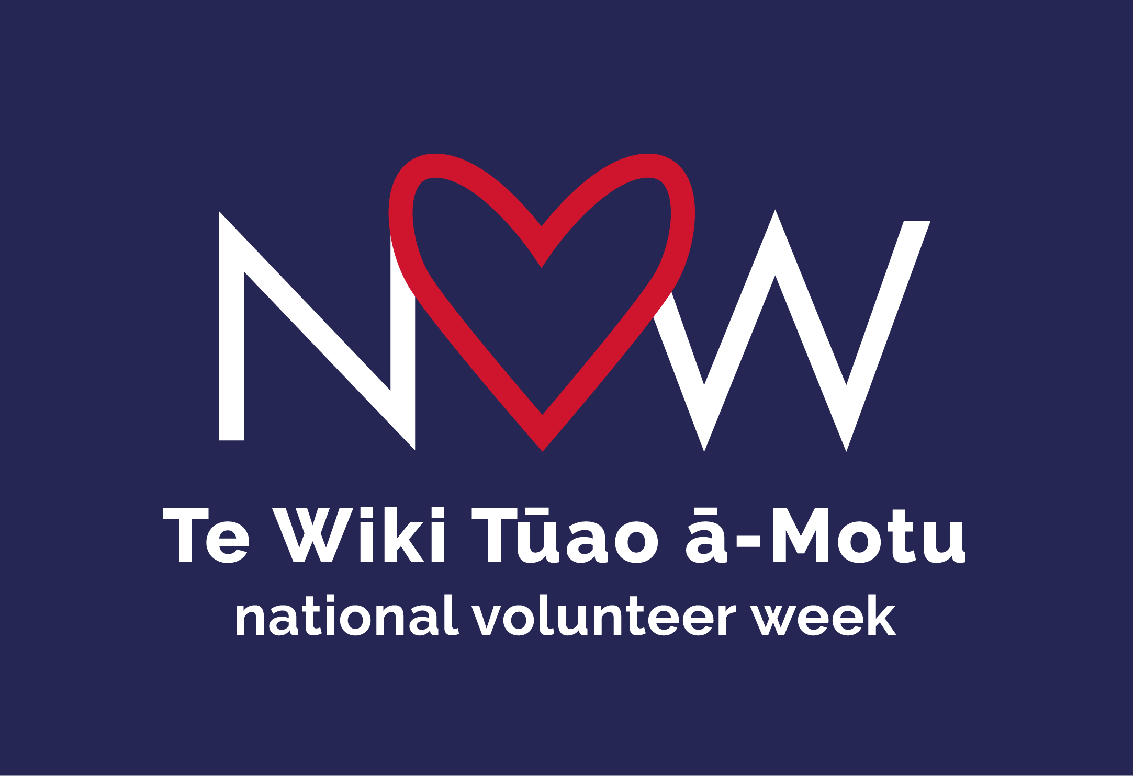

>> Download here

EDITABLE TEMPLATES

Create your own social media posts and printed pieces with these editable Canva templates.

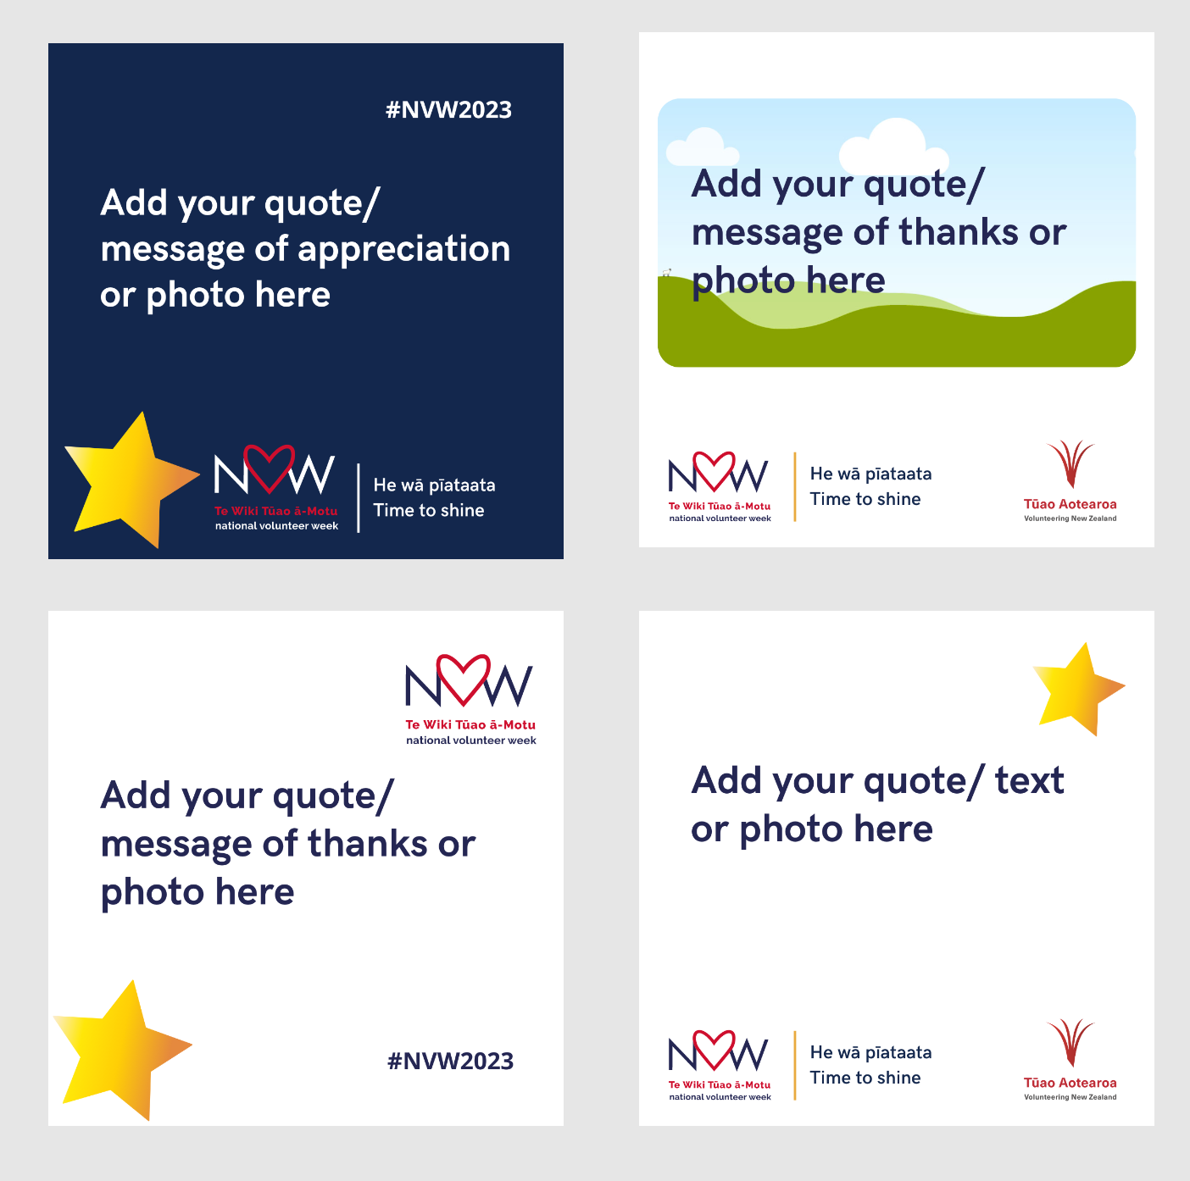

>> Download here

HEARTS AND STARS

Ideas for these Star and Heart templates – Print, hold up and take a photo with your team to share on social media. add your own text and/or image.

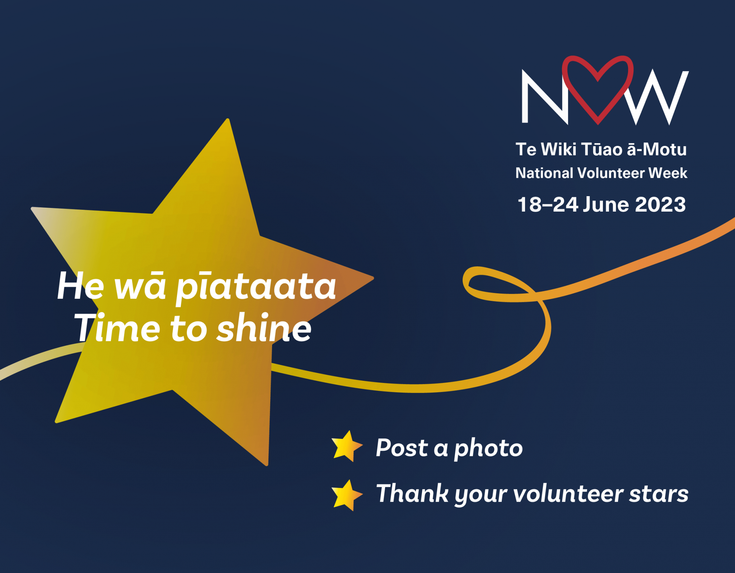

>> Download here

- Facebook: @volunteeringNZ facebook.com/VolunteeringNZ
- Instagram: @volunteeringnzinstagram.com/volunteeringnz
- LinkedIn: @volunteering New Zealandlinkedin.com/company/volunteering-new-zealand

VOLUNTEERING STATISTICS

- Approximately 21.5% of New Zealanders undertake volunteer work.
- Adding in informal and casual volunteering, 50.7% of adults have done some volunteer work in the last month.
- Of those who have volunteered, 30.2% volunteered through an organisation and 36% volunteered directly
- The value of formal volunteering is estimated at $4 billion per annum.
- New Zealanders contribute a total of around 159 million hours of formal volunteer labour each year.
- The number of people volunteering for an organisation has declined from 1.2 million in 2013 to 1 million in 2018.
Source: Statistics New Zealand Labour Market Statistics

CONTACT

For all media and NVW2023 enquiries please contact:

Margaret McLachlan
Communications Manager
Volunteering New Zealand
P 027 2478047
margaret@volunteeringnz.org.nz

